**Dranix Distributors, Inc.**

Tacloban City

Thru: HR Department

**Dear Sir/Maam:**

God’s Grace!

The undersigned wishes to apply in your good organization as **Warehouse Supervisor.**

Currently, I am working for the **COMMISSION ON POPULATION-08** as a **DATA ENCODER** for the Responsible Parenting Movement Advocacy Program of the agency for 5 years now, I am proud to say that working for this national government entity has equipped me knowledge not only in encoding particularly but in its programs and projects also, in my 5 years in the commission I am assigned as ***Acting-Secretary for the Regional Director, Assistant Storekeeper for the Supply Officer and Program Assistant for the program implementation of the Technical Services Division.*** I just wanting to say that I am very versatile in all tasks given to me, with a proper instructions and a proper training, I will assure that I’ll be excellent as a Warehouse Supervisor.

Unfortunately I did not get my college degree because of some certain circumstances but I am an accounting aspirant which in fact I am an under-graduate of this very interesting course. Maybe I am not qualified as far as educational attainment is concern, but in spite of my lack of education, I’m very much willing to learn new things in your great organization, because in my own point of view, sometimes success is not measured by diploma alone. As a matter of fact working for POPCOM-08 equipped me training and skills that can be an asset in your organization.

I have also my sales background as an active direct seller and network marketer of several multi-level marketing companies.

Hoping by god’s grace and mercy a chance to be a part of your organization will become a big opportunity for me.

I would appreciate an opportunity to come to your good office for an interview at your most convenient time. You can reach me anytime at this number **09079370872.**

Attached herewith is my personal information for your perusal.

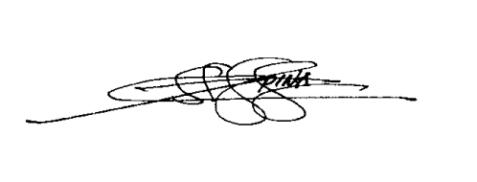Sincerely yours,

**JUNIL O. OPINA**

Applicant

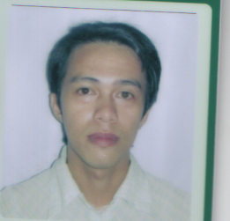

**JUNIL OLEDAN OPINA**

Brgy.78, Marasbaras, Tacloban City

09079370872

[junilopina14@gmail.com](mailto:junilopina14@gmail.com)

**Personal Information:**

Age: 26 yrs. Old

Birthday: June 27, 1988

Civil Status: Married

Sex: Male

Religion : Born Again Christian

**Skills:**

* Computer Literate (MS Office, MS Excel, MS Powerpoint)
* Good Leadership Skill
* Good Communication Skills
* Good Sales Marketing Skills

**Education Background:**

College – St. Pauls School of Business and Law

Bachelor of Science in Accountancy (Undergraduate)

2006

Eastern Visayas State University

Bachelor of Industrial Technology Major in Drafting (Undergraduate)

2004-2006

Secondary – Sagkahan National High School

2000-2004

Elementary – Rizal Central School

Honor Student

1996-2000

Marasbaras Community School

Honor Student

1995-1996

**Employment Record:**

* Bounty Agro Ventures Inc. **(Merchandiser**) August 2009 – October 2009
* Commission on Population Regional Office VIII **(Job Order)** Dec.7, 2009 - Present
* **RPM** *(Responsible Parenting Movement*) **Data Encoder**

**\*** *Online Data Base In-Charge*

*\* Providing admin related assistance to the trainings/seminars conducted by POPCOM*

* **Office Clerk/Assistant Storekeeper**

**Affiliation:**

* **Regional Head , Visayas Area – Infinity & Leverage Network**

**Seminar Workshop Attended:**

* **Parent Education on Adolescent Health and Development**

(Commission on Population 8) – Resource Speaker

* **Training** **on Basic** **Demography**

(Commission on Population 8)

* **Training on Basic POPDEV Planning**

(Commission on Population 8)

**Character References:**

**LEO R. RAMA**

Retired Regional Director

Commission on Population 8

09285200320

**HON. ERWIN BIDUA**

Brgy. Chairman

Brgy.78, Marasbaras, Tacloban City

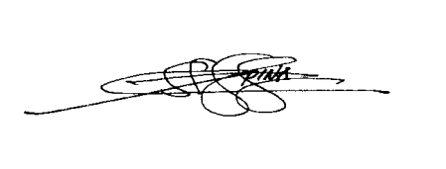I certify that the above aforementioned are true and correct.

**JUNIL O. OPINA**